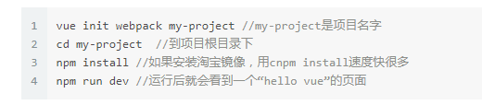

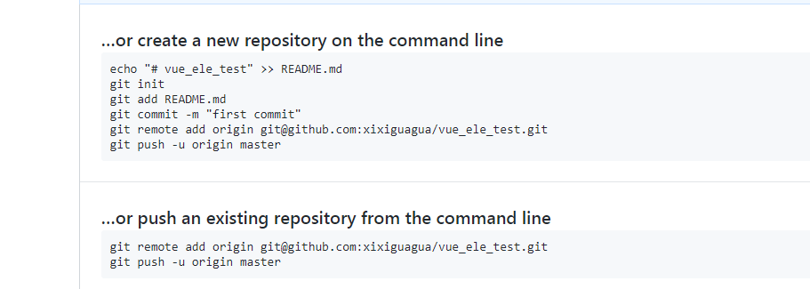

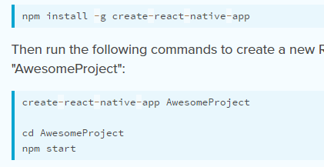

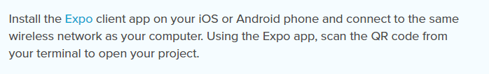

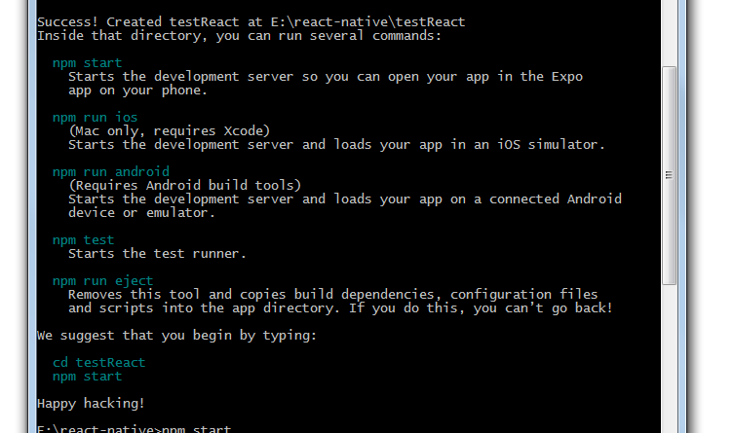

打包命令



react-native bundle --entry-file index.ios.js --platform ios --dev false --bundle-output ./ios/bundle/index.ios.jsbundle --assets-dest ./ios/bundle

(参考：http://www.jianshu.com/p/ce71b4a8a246)





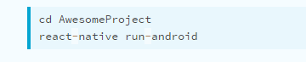

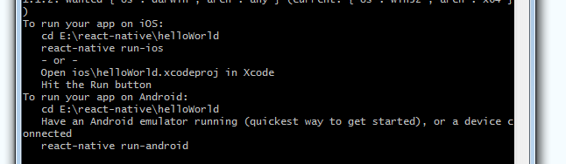

动态页：

用户feed流：<http://api-t.iqiyi.com/feed/get_user_feeds>

来自泡泡圈：<http://api-t.iqiyi.com/feed/get_feeds>

<http://api-t.iqiyi.com/feed/get_feed>

feed点赞: <http://api-t.iqiyi.com/feed/agree>

feed取消点赞：<http://api-t.iqiyi.com/feed/agree>

feed 删除：<http://api-t.iqiyi.com/feed/delete>

feed举报：<http://api-t.iqiyi.com/feed/report_feed>

feed浏览数：<http://api-t.iqiyi.com/feed/read_inc>

feed评论列表：<http://sns-comment.iqiyi.com/v2/comment/get_comments.action>

feed评论发布：<http://sns-comment.iqiyi.com/v2/comment/publish.action>

feed评论点赞：<http://sns-comment.iqiyi.com/v2/comment/like.action>

feed评论取消点赞：<http://sns-comment.iqiyi.com/v2/comment/remove_like.action>

feed评论删除：<http://sns-comment.iqiyi.com/v2/comment/delete_comment.action>

feed评论举报：<http://sns-comment.iqiyi.com/v2/comment/report_comment.action>

feed评论回复：<http://sns-comment.iqiyi.com/v2/comment/publish.action>

实名制验证：<http://passport.iqiyi.com/apis/user/verify_status.action>

圈子页：

我的圈子：<http://paopao.iqiyi.com/apis/e/starwall/userCollectWall.action>

热门圈子：<http://mixer.video.iqiyi.com/recommend/circles>

视频页：

他上传的视频：[http://mixer.video.iqiyi.com/jp/mixin/videos/users/](http://mixer.video.iqiyi.com/jp/mixin/videos/users/1) $!{uid}

播单页：

用户播单列表：[http://mixer.video.iqiyi.com/mixin/playlists/users/](http://mixer.video.iqiyi.com/mixin/playlists/users/1229472989) $!{uid}

播单详情：<http://mixer.video.iqiyi.com/jp/mixin/playlists/>$!{bodan.id}

订阅页（客态）：

订阅：<http://timeline.iqiyi.com/timeline-api/get_friends_recent_feeds>